

Practices for Secure Software Report

Table of Contents
Document Revision History 3
Client 3
Instructions 3
Developer 4
1. Algorithm Cipher 4
2. Certificate Generation 4
3. Deploy Cipher 4
4. Secure Communications 4
5. Secondary Testing 4
6. Functional Testing 4
7. Summary 4
8. Industry Standard Best Practices 4

Document Revision History

Version | Date | Author | Comments
1.0 | [Date] | [Your Name]

Client



Instructions

Submit this completed practices for secure software report. Replace the bracketed text with the relevant information. You must document your process for writing secure communications and refactoring code that complies with software security testing protocols.

- Respond to the steps outlined below and include your findings.
- Respond using your own words. You may also choose to include images or supporting materials. If you include them, make certain to insert them in all the relevant locations in the document.
- Refer to the Project Two Guidelines and Rubric for more detailed instructions about each section of the template.

Developer
Trevor Powers

Algorithm Cipher

For the project, I incorporated SHA-256 as the fundamental hashing algorithm to ensure data integrity in the Artemis Financial app. SHA-256 is a modern hashing algorithm that ensures data integrity by generating a checksum that confirms that the data was not altered during transmission. We did not use other algorithms like MD5 or SHA-1 because they are obsolete compared to SHA-256, which is considered a reliable algorithm to ensure data security, especially in financial-related systems.

The app uses Java’s MessageDigest class to generate the checksum from a unique data string, ensuring that the hashing process remains secure and consistent. This hashing algorithm does not require any encryption keys because the hashing process is one-way encryption, unlike other encryption algorithms that require keys to ensure security. Nevertheless, the system uses HTTPS to ensure secure communication between the client and the server, which uses TLS encryption to ensure security during transmission.

Over the years, encryption algorithms have continued to improve to address emerging security issues in the digital world. Some of the encryption algorithms that were used in the past are now considered insecure compared to modern algorithms like SHA-256 and TLS encryption. By incorporating modern encryption algorithms like SHA-256, the app ensures that financial data remains secure, meeting modern security requirements.

Certificate Generation
Insert a screenshot below of the CER file.

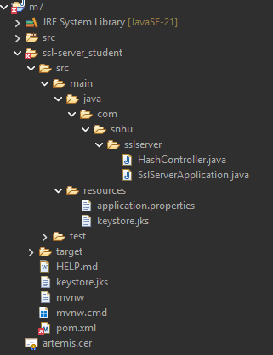

Deploy Cipher
Insert a screenshot below of the checksum verification.

Secure Communications
Insert a screenshot below of the web browser that shows a secure webpage.

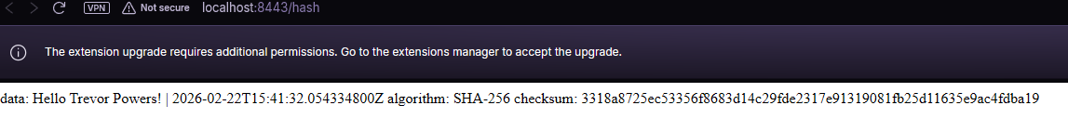

Secondary Testing
Insert screenshots below of the refactored code executed without errors and the dependency-check report.

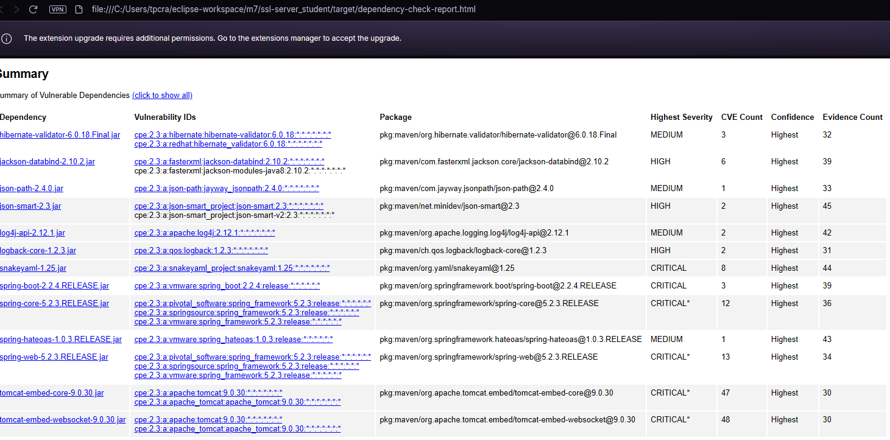

Functional Testing
Insert a screenshot below of the refactored code executed without errors.

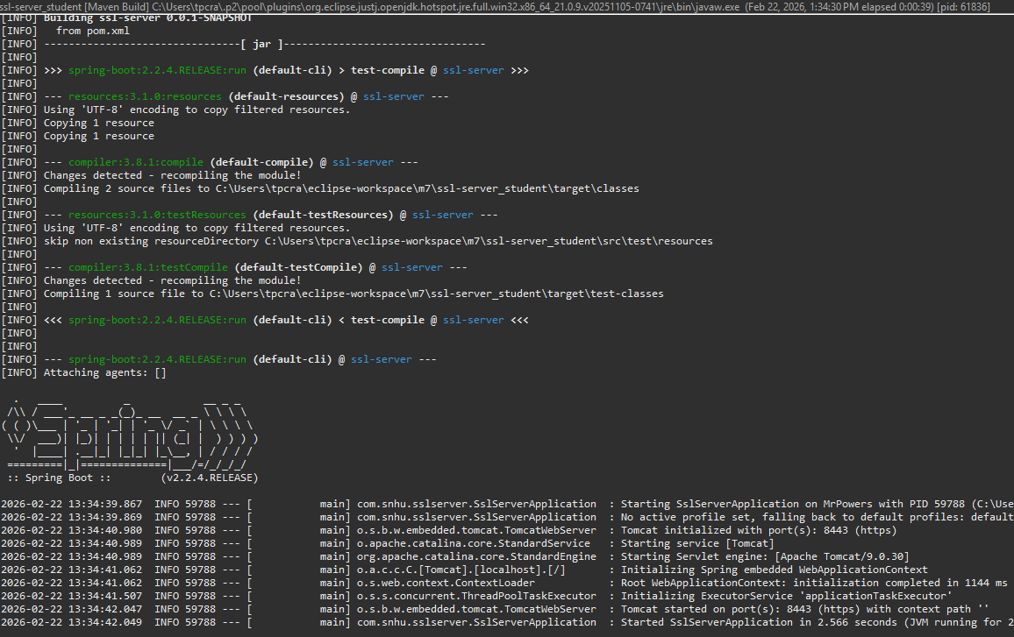

Summary

In the project, the Artemis Financial app has been refactored to enhance security and ensure that communication and data exchange are secure. In the initial app, there was no way of ascertaining the integrity of the data being sent. In addition, there was no way of ensuring that the communication was encrypted. In the refactored app, a SHA-256 checksum check has been implemented to ensure the integrity of the data being sent. In the same vein, the app has been configured to run via HTTPS using a self-signed SSL certificate. This has ensured that the app has multiple security features built in.

In the project, the following steps have been followed: First, the existing code has been analyzed to identify the vulnerabilities. Following the identification of the vulnerabilities, the security features have been integrated via refactoring. In the refactored app, the SHA-256 checksum check has been implemented, and the app has been configured to run via HTTPS using a self-signed SSL certificate. In the refactored app, the app has been run successfully, and the /hash endpoint has been accessed to verify that the encryption and integrity features are working as expected. In the same vein, the app has been subjected to a second check via the OWASP Dependency-Check tool to verify that no vulnerabilities have been introduced in the development process.

In the project, the refactored app has been designed to provide a high level of security, which is in line with the goals of Artemis Financial in providing a high level of security in the apps used for client financial information.

Industry Standard Best Practices

During the entire refactoring process, I made sure to abide by all the industry-standard security coding guidelines, thereby enhancing the security of the application while maintaining its functionality. One such security coding standard is the use of the SHA-256 hashing algorithm, which is a reliable, widely accepted, and trusted standard for maintaining the integrity of the application’s data. The use of a modern standard, as opposed to older, outdated algorithms, will help minimize the risk of security breaches and tampering.

The other security coding standard that I followed during the development of the application is the use of HTTPS protocol with SSL/TLS encryption and a keystore for the protection of sensitive information during transit. This is particularly important for a financial application where security is paramount. Another security standard that I followed is the use of Java security libraries, which are more reliable and trustworthy than writing custom crypto code, thus minimizing security pitfalls.

Finally, I also made sure to perform static security testing using OWASP Dependency Check, which will help identify any potential security vulnerabilities within the project’s dependencies. These security coding standards will help enhance the security, confidentiality, and integrity of the application, thus aligning well with the security ethos of the company, which is paramount in handling client finances professionally.

